Frontend PRD — AI Turf Booking System
1. Product Overview
Build a Streamlit-based frontend that allows customers to:
- Create an account and log in
- Browse sports facilities
- Check availability
- Book turfs and courts through an AI assistant
- Rent equipment
- View, cancel, and reschedule bookings
- View membership details
- Ask questions about rules, pricing, and policies
The frontend should feel like a simple sports-facility booking application with an integrated AI chatbot.
2. Goals
The frontend must:
- Make booking a facility fast and understandable.
- Clearly show available time slots and prices.
- Require user confirmation before creating, cancelling, or rescheduling a booking.
- Display only data belonging to the logged-in customer.
- Make AI responses actionable through buttons and forms.
- Handle errors and unavailable slots clearly.
3. Target User
Customer
A customer wants to:
- Find an available facility
- Book a time slot
- Add equipment
- Apply membership benefits
- Manage existing bookings
- Ask questions without navigating multiple pages
An admin dashboard is not part of the initial frontend MVP.
4. Navigation Structure
The application should contain:
Login / Signup
↓
Main Application
├── Dashboard
├── AI Assistant
├── Book a Facility
├── My Bookings
├── Membership
└── Profile
For smaller screens, use a sidebar or expandable navigation menu.
5. Main Screens
5.1 Login Screen
Purpose
Allow registered users to access their account.
Components
- Application logo/name
- Email or phone input
- Password input
- Login button
- Link to Signup
- Error message area

Validation
- Required email/phone
- Required password
- Invalid credentials message
- Session created after successful login
Success behavior
Redirect the user to the Dashboard.
5.2 Signup Screen
Components
- Full name
- Email
- Phone number
- Password
- Confirm password
- Signup button
- Link to Login
Validation
- All required fields must be completed.
- Email must have a valid format.
- Phone number must be valid.
- Passwords must match.
- Duplicate email or phone must show a clear error.
- Password must never be displayed or stored in plain text.
Success behavior
Create the account and redirect the user to the Dashboard or Login screen.

5.3 Dashboard
Purpose
Provide a quick overview of the customer’s account.
Sections
Welcome section
Welcome, [Customer Name]
Quick actions
- Book a facility
- Ask AI Assistant
- View bookings
- View membership
Upcoming booking card
Display:
- Facility name
- Date
- Start and end time
- Booking status
- Total amount
- View details button
If there are no upcoming bookings:
You have no upcoming bookings.
[Book a Facility]
Membership card
Display:
- Membership type
- Active/inactive status
- Expiry date
- Discount benefit
Recent bookings
Show the latest bookings with their statuses.
5.4 AI Assistant
Purpose
Allow users to interact with the booking system using natural language.
Example requests
Book badminton tomorrow at 6 PM.
What is the cancellation policy?
Show my upcoming bookings.
Can I rent two badminton rackets?
Layout
--------------------------------
AI Turf Assistant
--------------------------------
Chat messages
--------------------------------
Message input
[Send]
--------------------------------
AI response types
The frontend should support:
- Plain text responses
- Facility availability cards
- Booking summary cards
- Confirmation prompts
- Cancellation confirmation prompts
- Rescheduling forms
- Price breakdowns
- Suggested action buttons
Example availability response
Badminton courts available at 6:00 PM:

[BC1]
₹330
6:00 PM – 7:00 PM
[Select]

[BC2]
₹330
6:00 PM – 7:00 PM
[Select]
Confirmation response
Please confirm your booking:

Facility: Badminton Court 1
Date: 10 September 2026
Time: 6:00 PM – 7:00 PM
Booking price: ₹330
Equipment: None

[Confirm Booking] [Cancel]

Important behavior
The frontend must not assume that an action succeeded merely because the AI generated a response. It should display success only after the backend confirms the operation.

5.5 Book a Facility
Purpose
Provide a form-based alternative to the AI assistant.
Form fields
- Facility type
- Date
- Start time
- Duration
- Equipment
- Membership information
- Price summary
Facility types
- Badminton
- Football
- Tennis
- Multipurpose room
Flow
Select facility
↓
Select date and time
↓
Check availability
↓
Select equipment
↓
View price
↓
Confirm booking -> Booking Success
Availability states
Available
Available
[Book Now]
Unavailable
Unavailable
The frontend should suggest alternative facilities or times where available.
Loading
Checking availability...
Error
Availability could not be loaded.
[Try Again]
5.6 Booking Details and Confirmation
Before creating a booking, show a complete summary:
- Facility
- Date
- Time
- Duration
- Base price
- Peak surcharge
- Membership discount
- Equipment charges
- Deposit
- Final amount

Example:
Booking Summary
Badminton Court 1
10 September 2026
6:00 PM – 7:00 PM

Base price ₹300
Peak surcharge ₹30
Membership discount -₹0
Equipment ₹100
Deposit ₹0
----------------------------------------
Total ₹430

[Confirm Booking] [Go Back]
The Confirm button should be disabled while the request is being processed.
5.7 Booking Success Screen
Display:
- Success message
- Booking ID
- Facility
- Date and time
- Total amount
- Payment status
- Equipment details
- Button to view booking
- Button to return to Dashboard

Example:
Booking confirmed!
Booking ID: BKG1006
Badminton Court 1
10 September 2026
6:00 PM – 7:00 PM
Total: ₹330

[View Booking] [Back to Dashboard]
5.8 My Bookings
Purpose
Allow users to view and manage their bookings.
Tabs or filters
- Upcoming
- Past
- Cancelled
Booking card
Display:
- Booking ID
- Facility
- Date
- Time
- Amount
- Booking status
- Payment status
- Equipment
- View details button

Actions
For eligible bookings:
- Cancel booking
- Reschedule booking
Actions should not be shown or should be disabled when the booking is not eligible.
5.9 Booking Details
Display
- Booking ID
- Facility
- Booking date
- Start and end time
- Duration
- Booking status
- Payment status
- Price breakdown
- Equipment rentals
- Created date
Available actions
[Cancel Booking]
[Reschedule Booking]
Status examples
Confirmed
Cancelled
Completed
Rescheduled
Pending

5.10 Cancellation Flow
Step 1: Eligibility
The frontend requests cancellation eligibility from the backend.
If eligible:
This booking is eligible for a refund of ₹330.
Refunds are returned to the original payment method
and may take 3–5 business days.
[Continue Cancellation] [Keep Booking]
If not eligible:
This booking is less than 2 hours away and is non-refundable.
Do you still want to cancel?
[Cancel Booking] [Keep Booking]
Step 2: Confirmation
The user must explicitly confirm.
Step 3: Result
Success:
Booking cancelled successfully.
Refund amount: ₹330
Failure:
The booking could not be cancelled.
[Try Again]
5.11 Rescheduling Flow
Step 1: Select new slot
Display:
- New date
- New start time
- Duration
- Available facilities or slots
Step 2: Eligibility
Show:
- Whether the booking is eligible
- Remaining reschedule count
- Whether the new slot is available
Step 3: Price comparison
Current price: ₹330
New price: ₹400
Additional amount: ₹70
or:
Current price: ₹400
New price: ₹330
Refund difference: ₹70
Step 4: Confirmation
Reschedule your booking?
Current:
Badminton Court 1
6:00 PM – 7:00 PM
New:
Badminton Court 2
7:00 PM – 8:00 PM
Price difference: ₹0
[Confirm Reschedule] [Cancel]
If the booking has already been rescheduled once:
This booking cannot be rescheduled again.

5.12 Equipment Selection
Equipment list
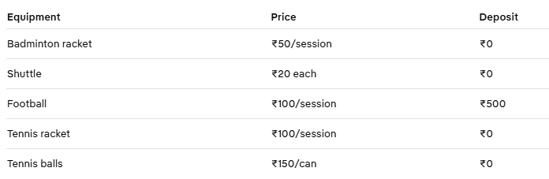
Components
- Equipment name
- Quantity selector
- Price
- Deposit information
- Add/remove controls
Membership discounts should not be applied to equipment charges.
5.13 Membership Screen
Display
- Membership status
- Plan name
- Price
- Start date
- Expiry date
- Booking discount
- Priority access information
Example:
Annual Membership
Status: Active
Valid until: 15 January 2027
Booking discount: 15%
Priority peak access: Included
For users without membership:
You do not have an active membership.
The initial MVP may display membership information without supporting membership purchase.
5.14 Profile Screen
Display and edit
- Name
- Email
- Phone number
- Membership status
- Account creation date
Security
- Never display the password.
- Provide a change-password option if implemented.
- Show a logout button.
6. User Flows
6.1 Normal Booking Flow
Login
↓
Dashboard
↓
Book a Facility or AI Assistant
↓
Select facility
↓
Select date and time
↓
Check availability
↓
Add equipment
↓
Review price
↓
Confirm
↓
Booking success
6.2 AI Booking Flow
User enters request
↓
AI interprets intent
↓
Frontend displays available options
↓
User selects an option
↓
Frontend displays price summary
↓
User confirms
↓
Backend creates booking
↓
Frontend displays booking confirmation

6.3 Cancellation Flow
My Bookings
↓
Select booking
↓
Cancel Booking
↓
Show refund eligibility
↓
User confirms
↓
Backend cancels booking
↓
Show result
7. Frontend State Requirements
The frontend must support these states:
Initial
Loading
Success
Empty
Validation error
Backend error
Unavailable
Confirmation required
Processing
Session expired

Example loading messages
- Checking availability...
- Calculating price...
- Creating your booking...
- Cancelling booking...
- Loading your bookings...
Buttons must be disabled during processing to prevent duplicate requests.
8. Error Messages
Use clear, actionable messages.
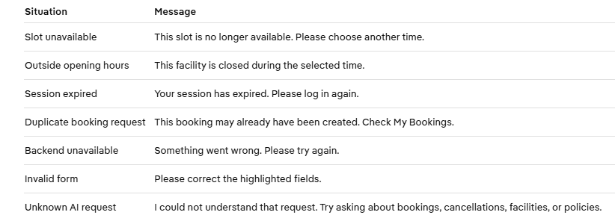
9. Design Requirements
Visual style
- Clean and modern sports-focused interface
- High contrast
- Clear primary buttons
- Consistent spacing
- Responsive layout
- Minimal decoration around important booking information

Color meaning
Use consistent status colors:
Green → Available / Confirmed / Success
Yellow → Pending / Processing
Red → Cancelled / Error / Unavailable
Blue → Informational / Membership
10. Accessibility
The frontend should:
- Use readable font sizes
- Provide labels for all inputs
- Make buttons descriptive
- Support keyboard navigation where possible
- Avoid color-only status indicators
- Show validation errors near the relevant fields
- Use clear date and time formats
- Confirm destructive actions such as cancellation
11. Data and Session Rules
The frontend must:
- Store the authenticated session safely.
- Send the authenticated user context with requests.
- Never allow a user to enter a different customer ID to access another account.
- Clear session data on logout.
- Redirect unauthenticated users to Login.
- Refresh booking data after booking, cancellation, or rescheduling.
- Show backend-confirmed values rather than calculating final prices independently.
The frontend may display calculated values, but the backend remains the source of truth.

12. Streamlit Page Structure
Suggested structure:
streamlit_app/
├── app.py
├── components/
│ ├── navbar.py
│ ├── booking_card.py
│ ├── availability_card.py
│ ├── price_summary.py
│ ├── confirmation_dialog.py
│ └── status_message.py
│
├── pages/
│ ├── login.py
│ ├── signup.py
│ ├── dashboard.py
│ ├── assistant.py
│ ├── book_facility.py
│ ├── bookings.py
│ ├── booking_details.py
│ ├── membership.py
│ └── profile.py
│
└── session.py

13. MVP Acceptance Criteria
The frontend MVP is complete when:
- A user can sign up and log in.
- An unauthenticated user cannot access booking pages.
- The Dashboard displays account and booking information.
- A user can search for facility availability.
- Unavailable slots are clearly identified.
- A user can select equipment.
- A complete price summary is displayed.
- A user must confirm before booking.
- A successful booking displays a booking ID.
- A user can view booking history.
- A user can cancel an eligible booking.
- A user can reschedule an eligible booking.
- A user can ask policy questions through the AI Assistant.
- AI actions require explicit user confirmation.
- Duplicate submissions are prevented.
- Backend errors are displayed clearly.
- User data is not mixed between accounts.
- The application works after page navigation and session refresh.
14. Frontend MVP Scope
Included
Login
Signup
Dashboard
AI Assistant
Facility search
Availability
Booking
Price summary
Equipment selection
Booking history
Cancellation
Rescheduling
Membership display
Profile
Error handling
Session handling
Excluded initially
Online payment gateway
Admin dashboard
Push notifications
Email notifications
Mobile application
Advanced analytics
Live chat with staff
FastAPI separation
Multi-location support
The frontend’s core responsibility is to make the booking process clear and safe. The AI can understand user requests, but the interface must always show the actual facility, time, price, and confirmation state before changing booking data.

